Recconaissance of Large-Scale Dolines in the Al-Abyar–Benina Area, NE Libya
Mohamed S. Al Faitouri^{1,*}, Ahmed M. Muftah¹, Kalifah A. Ashahomi², Saad K. Elebaidi¹, Hwaidi A. Errishi³, and Osama A. El Fallah¹
¹ Department of Earth Sciences, Faculty of Science, University of Benghazi, P.O.Box 1308, Benghazi, Libya.
² Arabian Gulf Oil Company, Exploration Division, Geology Department, Benghazi, Libya
³ Department of Geography, Faculty of Arts, Benghazi University, P.O. Box 1308 -Benghazi, Libya
*Corresponding author: Mohamed.Alfaitouri@uob.edu.ly

استطلاع الدولين كبيرة الحجم في منطقة الأبيار– بنينا، شمال شرق ليبيا

محمد سالم الفيتوري^{1،*}، أحمد محمد مفتاح²، خليفة أحمد الشحومي²، سعد خميس العبيدي¹، هويدي عبدالله الريشي³، أسامة عبدالله الفلاح¹
¹قسم علوم الأرض، كلية العلوم، جامعة بنغازي، بنغازي ، ليبيا.
²شركة الخليج العربي للنفط، بنغازي ، ليبيا.
³قسم الجغرافيا، كلية الآداب، جامعة بنغازي، بنغازي ، ليبيا.

Abstract
Karst features are widespread, yet many remain insufficiently documented despite their scientific and environmental importance. The present study focuses on the area between Al-Abyar and Benina villages in Cyrenaica, where large-scale dolines have developed within the Upper Miocene Wadi Al Qattarah Formation. Field surveys and morphometric analyses revealed sixteen representative dolines distributed across two geomorphic levels: the coastal fluvial plain and the first plateau of Al Jabal al Akhdar. These dolines vary in size, morphology, and genesis, ranging from solutional depressions to collapse and alluvial dolines. Their formation is interpreted in relation to tectonic evolution, groundwater circulation, surface runoff dynamics, and lithological variability. The study highlights how structural discontinuities and lithological heterogeneity have controlled doline development, while human activities such as agriculture, groundwater extraction, and infrastructure expansion have contributed to their enlargement and reactivation. This anthropogenic influence increases the hazard potential of dolines, posing risks to land use and settlement stability. By integrating petrographic analysis, GIS mapping, and morphometric characterization, the research provides new insights into karst evolution in Cyrenaica and establishes a baseline for future comparative studies with other doline fields in Al Jabal al Akhdar. Ultimately, the findings emphasize the need for conservation strategies to protect these natural karst systems, not only for their geomorphological and hydrogeological significance but also for their potential value in geotourism and sustainable regional development.

Keywords: Collapse doline, Geomorphological features, Morphometric analysis, Wadi Al Qattarah, Cyrenaica.
الملخص
تتميز معالم الكارست بانتشار واسع، ومع ذلك لا تزال العديد منها غير موثقة بشكل كاف رغم أهميتها العلمية والبيئية. تركز الدراسة الحالية على المنطقة بين قريتي الأبيار وبنينا في برقة، حيث تطورت دولينات واسعة النطاق ضمن تكوين وادي القطارة في عصر الميوسين الأعلى. كشفت المسوحات الميدانية والتحليلات الشكلية عن ستة عشر دولين تمثيليا موزعة على مستويين جيوموروفيولوجيين: السهل النهري الساحلي والهضبة الأولى في جبل الأخضر. تختلف هذه الدولين في الحجم والشكل والنشأة، بدءا من الانخفاضات المحالية إلى الانهيار والدولين الطمي. يفسر تكوينها فيما يتعلق بتطور التكتونية، ودوران المياه الجوفية، وديناميكيات جريان السطح، والتغيرات الصخرية. تسلط الدراسة الضوء على كيف أن الانقطاعات الهيكلية والتباين الصخري سيطرت على تطور الدولين، بينما ساهمت الأنشطة البشرية مثل الزراعة، واستخراج المياه الجوفية، وتوسيع البنية التحتية في توسيعها وإعادة تفعيلها. يزيد هذا التأثير البشري من إمكانيات الدولين المخاطرة، مما يشكل مخاطر على استخدام الأراضي واستقرار المستوطنات. من خلال دمج التحليل البتروغرافي، ورسم خرائط نظم المعلومات الجغرافية، وتوصيف المورفومتري، يوفر البحث رؤى جديدة حول تطور الكارست في برقة ويضع أساسا للدراسات المقارنة المستقبلية مع حقول دولين أخرى في جبل الأخضر. في النهاية، تؤكد النتائج على الحاجة إلى استراتيجيات حفظ لحماية هذه الأنظمة الكارستية الطبيعية، ليس فقط لأهميتها الجيومورفولوجية والهيدروجيولوجية، بل أيضا لقيمتها المحتملة في السياحة الجيولوجية والتنمية الإقليمية المستدامة.

الكلمات الدالة: الحفر الغائرة، مظاهر التقاسيم السطحية، التحليل المورفومتري، وادي القطارة، برقة.
Introduction
Dolines, also referred to as sinkholes, are among the most distinctive geomorphological features of karst terrains. They represent closed depressions formed through a combination of lithological dissolution, hydrological processes, and structural controls within carbonate environments (Busetti, 2024). Globally, dolines have been studied for their geomorphological significance, hydrogeological implications, and associated hazards, particularly in regions where karstification plays a dominant role in shaping the landscape (De Waele & Gutiérrez, 2022; Goudie, 2024). Their occurrence is not only a matter of scientific interest but also of practical concern, as dolines can pose risks to infrastructure, agriculture, and groundwater resources. In karst regions, dolines vary widely in size, morphology, and genesis. They may develop through solutional processes, collapse of cave roofs, suffusion of unconsolidated sediments, or a combination of these mechanisms. The classification of dolines has therefore been the subject of considerable debate, with researchers emphasizing the need to integrate geomorphic, structural, and lithological criteria (Veress, 2022). While dolines are common features in many Mediterranean karst landscapes, their distribution and characteristics often reflect localized geological and climatic conditions. Understanding these variations is critical for reconstructing karst evolution and assessing environmental hazards (Zerga, 2024). In Northeast Libya, particularly within the Al Jabal al Akhdar region, dolines have been documented in several localities. Previous studies have highlighted doline fields in Msus (Faraj et al., 2016), Qasr Libya (El Amawy et al., 2010), and Ayn Zayanah (Salloum et al., 2022), demonstrating the widespread development of karst features in Cyrenaica. However, despite this growing body of research, the dolines situated between Al-Abyar and Benina remain poorly described in the scientific literature. This lack of systematic documentation represents a notable gap in regional karst studies, especially given the geomorphological diversity and environmental importance of the area. The present study seeks to address this gap by providing a comprehensive documentation and analysis of dolines developed within the Upper Miocene Wadi Al Qattarah Formation. By examining their spatial distribution, morphometric properties, and geological context, the research aims to clarify how lithological variability and structural discontinuities have influenced their genesis. At the same time, the study evaluates the geomorphological significance of these features and considers their potential environmental hazards, particularly in relation to human activities such as agriculture, groundwater extraction, and infrastructure development. Through the integration of field surveys, petrographic analysis, and GIS-based morphometric mapping, this work contributes new insights into karst development in Northeast Libya. Beyond its academic value, the study underscores the importance of conserving these natural features, which hold both scientific and touristic potential, and highlights their relevance to sustainable land-use planning and hazard management.
Location of the study area:
The study area is located in the northeastern part of Libya (Fig. 1). The geographical positions of the documented dolines are indicated in Table 1.
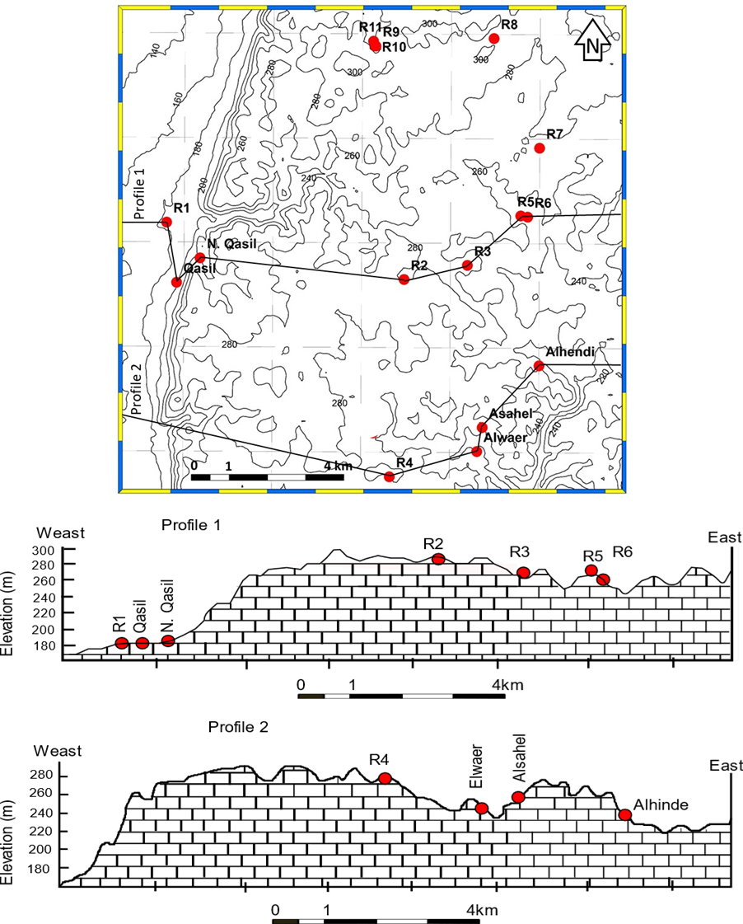
Fig. 1: Topographic map, with two cross sections (Profile 1 and Profile 2), shows the dolines (in red) altitudes, and their location.

Table 1. Listed the sixteen dolines and their geographical position.
Name | Latitude |  | Longitude
R1 |  | 32° 6'16.85"N |  | 20°19'12.21"E
R2 |  | 32° 5'28.67"N |  | 20°23'13.18"E
R3 |  | 32° 5'41.16"N |  | 20°24'17.28"E
R4 |  | 32° 2'38.74"N |  | 20°22'59.34"E
R5 |  | 32° 6'23.92"N |  | 20°25'11.11"E
R6 |  | 32° 6'22.92"N |  | 20°25'18.09"E
R7 |  | 32° 7'22.30"N |  | 20°25'29.82"E
R8 |  | 32° 8'56.51"N |  | 20°24'43.13"E
R9 |  | 32° 8'49.47"N |  | 20°22'43.40"E
R10 |  | 32° 8'49.61"N |  | 20°22'42.55"E
R11 |  | 32° 8'53.65"N |  | 20°22'40.98"E
Alwaer |  | 32° 3'0.92"N |  | 20°24'27.82"E
Asahel |  | 32° 3'21.58"N |  | 20°24'33.17"E
Alhendi |  | 32° 4'14.99"N |  | 20°25'30.32"E
Qasil |  | 32° 5'25.12"N |  | 20°19'22.71"E
North Qasil |  | 32° 5'46.27"N |  | 20°19'46.39"E

Geological setting
Ar Rajmah Group is divided into two formations, Benghazi Formation, "Middle Miocene" and the Wadi Al Qattarah Formation (Upper Miocene). This division is based on the differences in lithology and faunal content (Klen, 1974; Röhlich, 1974; El-Hawat and Abdulsamad, 2004). In the western region of Al Jabal al Akhdar, the Ar Rajmah Group represents the final cycle of sedimentation during the Miocene. In the western region of Al Jabal al Akhdar. Benghazi Formation consists of Massive limestones, white fossiliferous "mainly red algae" becoming dolomitic in certain levels, with sporadic dark-gray marl and calcareous clay in some places. The Wadi Al Qattarah Formation represents the upper rock unit of the Ar Rajmah Group. It is made up of oolitic limestone, white, soft to medium hard, porous, and gypsiferous at the upper part. Gigantic Gypsum crystals were deposited unconformably on the Tortonian oolitic deposits during the Messinian crisis of the Mediterranean Basin (For more details, see El Hawat 1980, El Hawat and Salem 1987, El Hawat and Abdulsamad, 2004).
Methodology
To achieve the goal of this study in determining the morphometric analysis of dolines, the karst landforms and the geological structural elements are studied. The data collected during the several field surveys include rock samples, photographs, and dimension measurements of the dolines. The laboratory work includes the petrographic thin-section preparation. The Geographic Information System (GIS) mapping was used to determine the spatial data and to produce the necessary maps in this paper. Google Earth imagery and a geological map of Benghazi (Klen, 1974) are also used. Dimensions of the concerned dolines and structural data have been measured and tabulated for mapping purposes. A total number of 16 measurement dolines have been performed, 14 of which are located on the first plateau in the Ar Rajmah region, whilst the remaining 2 are at the fluvial “coastal” plain in the Benina region. In order to understand the relationship between the structural data and morphometrics, the obtained results have been analyzed and plotted on maps and cross-sections along the two semi-parallel doline alignments. The Aspect tool identifies the direction that a downhill slope faces. In the output raster, the value of each cell represents the compass direction that the surface faces at a given location. Aspect is measured clockwise in degrees from 0° (due north) to 360° (returning to due north), completing a full circle. Flat areas with no downslope direction are assigned a value of -1 (ArcGIS Pro Web; https://pro.arcgis.com/en/pro-app/3.4/tool-reference/spatial-analyst/how-aspect-works.htm). Differential weathering and erosion of various rock types have resulted in significant relief variations (Rawat et al., 2015).
Description of the dolines:
Dolines are classified by Sauro (2003) according to several parameters, including size, geometrical shape, lithology, tectonics, and their origins (Figs. 2 a-d). All criteria are used to determine the karst dolines types, where the main types are classified as: 1) Normal dolines, or “accelerated corrosion” dolines; 2) Collapse dolines; 3) Subsidence dolines; 4) Cover dolines; 5) Intersection dolines; 6) Anthropogenic dolines.

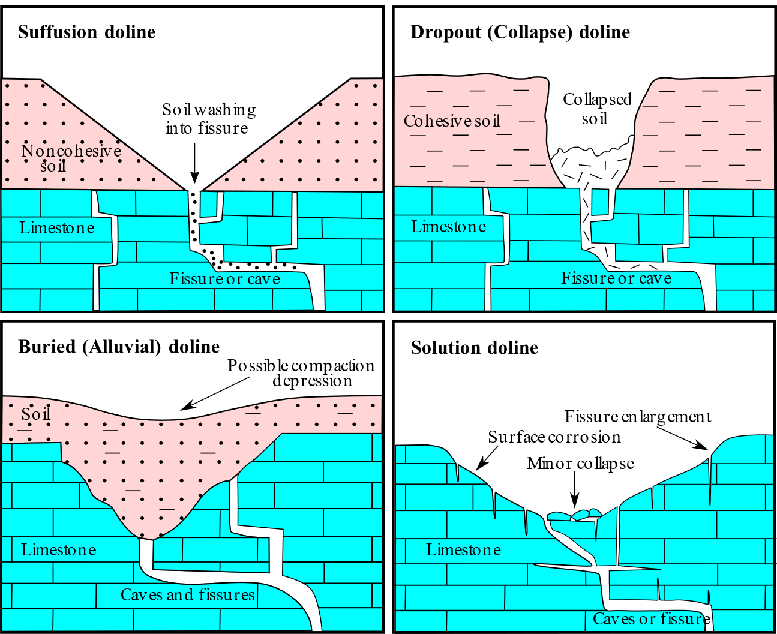
Figure 2: Sketch diagrams illustrate the identified types of dolines in the study area (modified after Sauro, 2003).
Dolines are natural closed depressions developed by the action of a subsurface groundwater system. The dissolution process of the underlying rocks created the solutional dolines. However, the collapse of the underlying caves within bedrock is responsible for forming the collapse doline. Dolines are of various types, as introduced by Kochanow (1999), Kranjc (2006), and Goudie (2024), based on their size and shape. The only four types of Sauro's dolines reported in this study are:
- Intersection dolines: They are created due to the intersection of empty or filled caves by the topographical surface, and they develop as a result of the weathering and hydrological processes (Fig. 2a).
- Collapse dolines: They are depressions formed by the dissolution of the underlying rocks and later collapse. This is completely different from the cave roof, in terms of type and size, and originates (Fig. 2b).
- Alluvial "Cover" dolines: They are created when unconsolidated clastic material absorbs into solution cavities that formed in a soluble rock underneath them (Fig. 2c).
- Solution Dolines: they form by dissolution or corrosion of the bedrocks by action of atmospheric water and groundwater (Fig. 2d).
The documented dolines in this study are categorized into 6 solutional dolines, 5 collapsed dolines, and 2 alluvial dolines. The measured dolines range in shape from bowl to funnel, with an opening outline either semicircular or elliptical. The diameter of the dolines ranges from 13 m to 771 m, whereas the depth varies from 1 to 27 m, with the deepest being the collapsed dolines.
Dolines R1, R3 and R8
These are solution dolines with maximum diameters varying between 140 meters and 34 meters and depths varying between 1 and 7 meters; the width-to-depth ratio varies between 0.03 and 0.05, indicating a bowl profile with gentle to moderate inclined sides (Fig. 3).
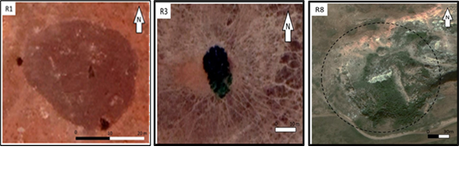
Figure 3: Google satellite images of R1, R3, and R8
Dolines R2 and R7
These are alluvial dolines with semi-circular openings and a (0.02 to 0.03) width-to-depth ratio, which give them a bowl-like profile with gently inclined peripheries. The base and the sides are covered with a thick layer of soil (Fig. 4).
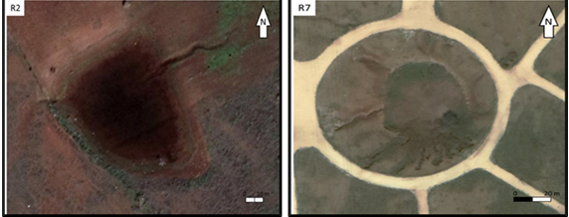
Figure 4: Google satellite images of R2 and R7
Dolines R4, R5, R6, R9, R10 and R11
These are small, dimensionally collapsed dolines, with maximum diameters varying between 4 and 14 meters and a depth of approximately 1 meter. The width-to-depth ratio varies from 0.07 to 0.14, which is indicative of the bowl outline. The opening of these dolines is irregular with gentle to steeply sloping sides (Fig. 5).
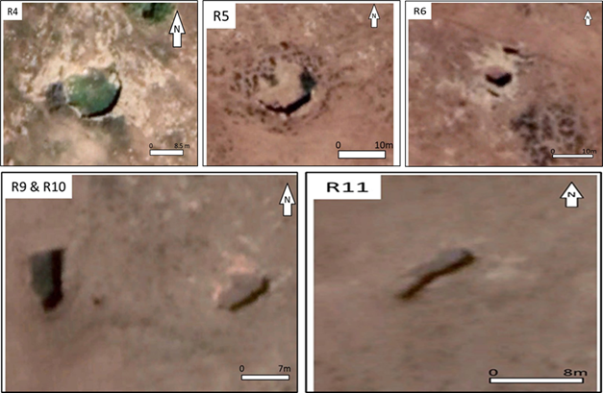
Figure 5: Google satellite images of R4, R5, R6, R9, R10, and R11

Alwaer Doline
It is a solution doline located on the plateau of the first escarpment. The doline’s opening is semi-circular with gently to moderately inclined sides. The width-to-depth ratio is 0.05, indicating a bowl-shaped cross-section (Fig. 6).
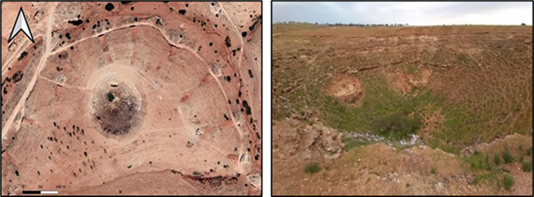
Figure 6: Google satellite images and General view of Alwaer Doline
Asahel Doline
This is possibly a collapsed doline located on the first escarpment. The doline has a semi-circular opening. The sides have a slightly steep profile in the top part and a moderate incline slope in the lower part. The floor of the doline is almost flat. Two tributaries feed the doline from the northern part (Fig. 7).
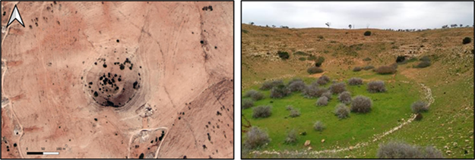
Figure 7: Google satellite images and General view of Al Sahil Doline

Alhendi Doline
This is a collapse doline located on the plateau of the first escarpment on the NE side of the NE running tributary. Doline has a semi-circular opening with slightly steep sides and bowl profiles (Fig. 8). These dolines contain small caves, partly modified, and these caves are located on the steep sides of the dolines, with deep exits in the bottoms, as seen in Alhendi doline.
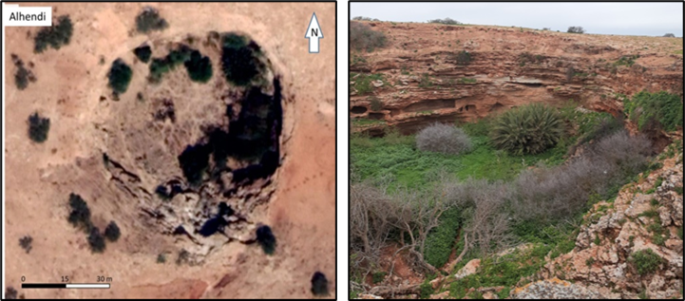
Figure 8: Google satellite images and General view of Alhendi Doline
Qasil Doline
This collapsed doline is located in the alluvial plain that borders the first escarpment. It has a funnel profile with a semi-circular opening and steep slope sides (Fig. 9).
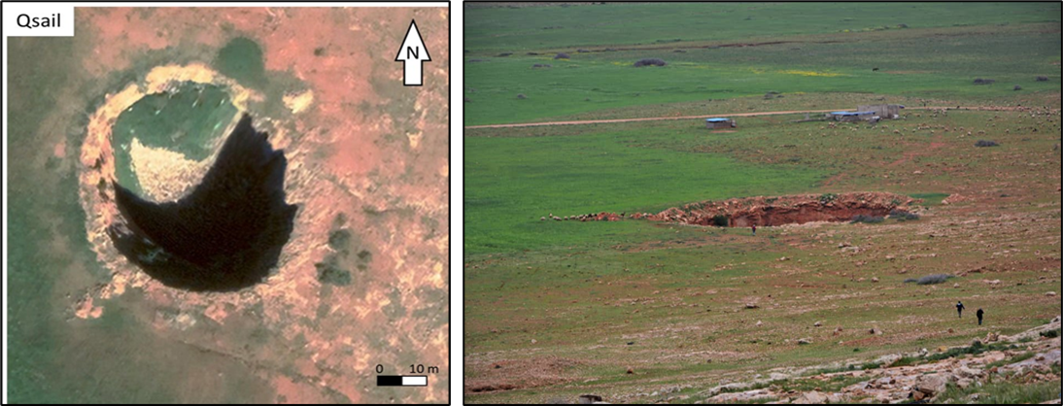
Figure 9: Google satellite image and General view of Qsail Doline

North Qasil Doline
This solution doline is located in the alluvial plain that borders the first escarpment. It has a bowl profile with a semi-circular opening and moderate to gentle slope sides (Fig. 10).
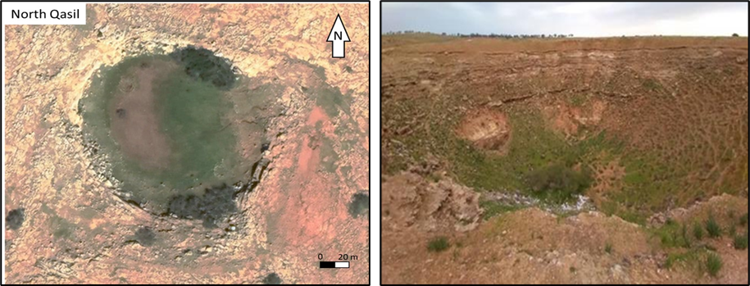
Figure 10: Google satellite images and General view of North Qasil Doline
Results and Discussions
The genesis of the Alhendi doline is a typical example of a submerged stream. However, the three dolines located in the western part of the study area on the fluvial plain are classified as solutional dolines, as in R1 and north Qasil; however, the collapse doline is represented by the Qasil doline. They are small-scale depressions developed in the lower plateaus. Furthermore, it is unclear if the initial form was a solution doline or a polygenetic form, such as a heavily altered collapse doline (Figs. 2). However, the development of dolines, which were detected by the joint intersections, such as Al Sahel and Qasil dolines, indicates a structural origin. However, the Alwaer, R2, and R7 are believed to be solutional dolines. The reported dolines are located at an altitude range from 120 to 140 m, and are about 50 m in diameter, reaching a depth of 30-50 m. Rock walls provide proof of collapsing, in which the northern slopes are gentle, while the southern slopes are very steep. These large depressions vary in terrain, with some characterized by steep, rocky slopes, while others feature caves or shafts on their floors. The forms and features that characterize these dolines are not typical of normal solution dolines. Regarding the lithological and petrographical characteristics, the karstification of the Wadi al Qattarah Formation has been considered significant in the development of karst landforms (Muftah et al., 2010; Abdulsamad et al., 2010). Doline karst in Wadi Al Qattarah Formation, as described from Asahel Doline, is characterized by chalky peloidal packstone microfacies with some pelloids, rare ooids, ostracodes, and euhedral dolomite crystals, with the presence of dolosparite cement in the lower part (Fig. 11a). The oolitic grainstone microfacies with common ooids (Fig. 11b), and sparite cement in the middle part, however, the fossiliferous dolostone microfacies with common euhedral dolomite crystals and dolosparite cement in the upper part (Fig. 11c).
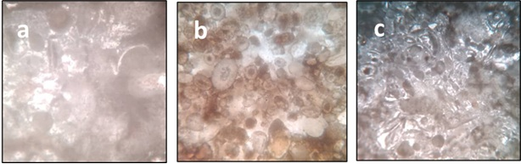
Figure 11: A Peloidal packstone microfacies, with some pelloids, rare ooids, ostracodes, rare dolomite euhedral crystals, and some dolosparite cement. B) Oolitic grainstone microfacies shows common ooids, and c) Fossiliferous dolostone microfacies shows euhedral dolomite crystals and dolosparite cement (All PPL and X40).

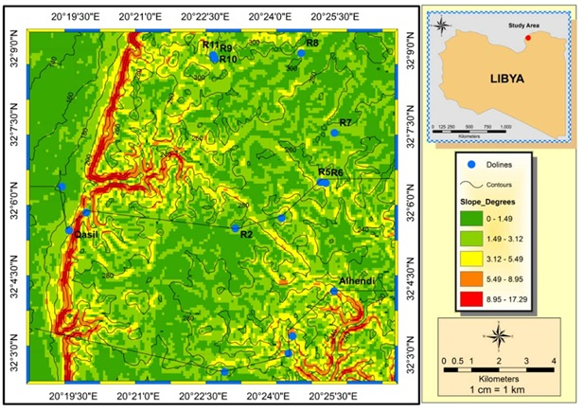
Figure 12: The map illustrates the slope degrees, where the highest coincide with the escarpment and along wadi walls. The rest of the map shows more or less low to moderate slope gradients.

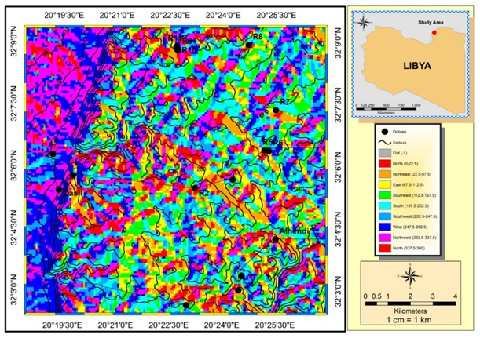
Figure 13: The map illustrates the slope direction, with the majority trend toward W, NW, and SW.
The morphometric analysis of the karst landforms performs different values of all parameters, whether considering (Bowl or funnel) or semi-circle or elliptical (Figs. 12, 13, and Table 2). The opening shape shows different values of the mean major axis / minor axis ratio (a/b), indicating a higher width in the former. The parameter elongation is defined as the ratio of the equivalent circular diameter to the major axis depth. The total number of bowls is 14, based on width and depth. On the other hand, we have only two shapes of a funnel. Another morphometric shape that we can see in our area is a semicircle or an elliptical shape. Accordingly, in terms of percentage, solution represents 31.25% of the total area, collapse and Small Collapse are 56.25%, and alluvial is only 12.5%. It indicates that the most doline types are collapsing (Fig. 8). The presence of steep scarps, deep, narrow valleys, springs, and straight stream courses suggests that the area remains in a youthful stage of the geomorphic cycle. A Digital Elevation Model (DEM) was used to delineate slope aspects within the study area. The slope aspects were classified as follows: north-facing (22.5°–67.5°), northeast-facing (67.5°–112.5°), east-facing (112.5°–157.5°), southeast-facing (157.5°–202.5°), south-facing (202.5°–247.5°), southwest-facing (247.5°–292.5°), west-facing (292.5°–337.5°), and northwest-facing (337.5°–360°). In general, the study area is structurally controlled by two dominant directions: northeast and northwest (Figs. 12 & 13).

Table ( 2). Morphometric characteristics of Dolines in the study area
Name | max | min | Area | Perimeter | Depth | Elevation | max.width/ depth | Profile | max/min | Opening shape | Type
Name | wide m | widem | m² | m | m | m | Ratio |  | width | Opening shape | Type
R1 | 34 | 26 | 671 | 93 | 1 | 183 | 0.03 | Bowl | 1.31 | Siem circular | Solution
2 | 98 | 68 | 4,900 | 264 | 2 | 279 | 0.02 | Bowl | 1.44 | Siem circular | Alluvial
3 | 18 | 12 | 184 | 52 | 1 | 270 | 0.06 | Bowl | 1.50 | Elliptical | Solution
4 | 14 | 13.5 | 137 | 47 | 1 | 282 | 0.07 | Bowl | 1.04 | Siem circular | Small Collapse
5 | 12 | 11 | 92 | 42.5 | 1 | 247 | 0.08 | Bowl | 1.09 | Siem circular | Small Collapse
6 | 4 | 3.5 | 13 | 13 | 1 | 246 | 0.25 | Funnel | 1.14 | Siem circular | Small Collapse
7 | 95 | 93.5 | 7,000 | 299 | 2 | 271 | 0.02 | Bowl | 1.02 | Siem circular | Alluvial
8 | 140 | 121 | 12,95 | 412 | 7 | 292 | 0.05 | Bowl | 1.16 | Siem circular | Solution
9 | 7 | 4 | 21 | 20 | 1 | 278 | 0.14 | Bowl | 1.75 | Elliptical | Small Collapse
10 | 9.5 | 5 | 32 | 23 | 1 | 278 | 0.11 | Bowl | 1.90 | Elliptical | Small Collapse
11 | 9 | 3 | 19 | 21 | 1 | 273 | 0.11 | Bowl | 3.00 | Elliptical | Small Collapse
Alwaer | 198 | 169 | 26,80 | 588 | 9 | 248 | 0.05 | Bowl | 1.17 | Siem circular | Solution
Asahel | 229 | 219 | 45,90 | 771 | 20 | 264 | 0.09 | Bowl | 1.05 | Siem circular | Collapse
Alhendi | 94 | 86 | 5,486 | 270 | 8 | 241 | 0.09 | Bowl | 1.09 | Siem circular | Collapse
Qasil | 54 | 38 | 1,973 | 16 | 27 | 198 | 0.50 | Funnel | 1.42 | Siem circular | Collapse
N. Qasil | 84 | 74 | 4,933 | 256 | 4 | 227 | 0.05 | Bowl | 1.14 | Siem circular | Solution

Discussion
The morphometric analysis revealed that dolines in the Al-Abyar–Benina area occur predominantly on two geomorphic levels: the coastal fluvial plain and the first plateau of Al Jabal al Akhdar. The majority exhibit bowl-shaped profiles, with diameters ranging from small depressions of less than 20 m to large features exceeding 200 m. Funnel-shaped dolines are less common, but their presence indicates localized collapse processes. Statistically, collapse dolines represent the dominant type (56.25%), followed by solutional dolines (31.25%) and alluvial dolines (12.5%). This distribution underscores the strong influence of structural discontinuities and lithological variability on doline genesis. Petrographic analysis of the Wadi Al Qattarah Formation demonstrates a vertical succession of microfacies—from peloidal packstone at the base, through oolitic grainstone in the middle, to fossiliferous dolostone at the top. These facies, coupled with the presence of fractures and joints, provided pathways for dissolution and collapse. For example, the Asahel and Qasil dolines show clear structural control, forming at the intersection of joint systems. In contrast, dolines such as Alwaer and North Qasil are primarily solutional, reflecting prolonged chemical weathering of carbonate rocks. Human activity has further influenced doline dynamics. Agricultural practices, groundwater extraction, and infrastructure development have reactivated or enlarged certain depressions, increasing their hazard potential. This anthropogenic impact highlights the need for integrating karst risk assessment into regional land-use planning. Overall, the dolines of Al-Abyar–Benina illustrate the polygenetic nature of karst development, where lithological composition, structural fabric, hydrological processes, and human intervention interact to shape the landscape. Fluvial processes play a significant role in modifying doline morphology in the study area. It increases erosion of the doline sides and floor, leading to its enlargement. Deposits entering dolines may alter their shape or partially fill them. Ultimately, it can affect doline hydrology, promoting further dissolution or collapse (Fisher et al., 2025). In addition, sediment dynamics during flooding accelerate the doline evolution. Fluvial sediments can partially fill dolines during floods, reducing their depth and promoting soil formation. However, this clogs swallets, causing ponding or overflow that widens dolines through sapping erosion. Moreover, runoff enhances water infiltration, intensifying chemical dissolution and potentially triggering collapses in response to groundwater levels fluctuatation (Siska et al., 2016). The findings not only fill a regional knowledge gap but also emphasize the broader significance of karst geomorphology in arid Mediterranean environments. Conservation of these features is crucial to the protection of natural heritage and promoting sustainable geotourism in Northeast Libya. These findings emphasize the importance of integrating doline hazard assessment into regional land-use and infrastructure planning. At the same time, recognizing the geotourism potential of these karst features offers opportunities for sustainable development through educational trails, geopark initiatives, and community-based tourism programs.

Conclusions
The studied karst dolines in the area between Al-Abyar and Benina are aligned into two sectors approximately 4km apart. All dolines are developed with upper Miocene “Tortonian” Wadi Al Qattarah Formation which consists of limestone differentiated into three microfacies as established in Asahel Doline, from bottom to top, the chalky peloidal packstone microfacies with some pelloids, rare ooids and ostracodes with rare euhedral dolomite crystal and dolosparite cement in the lower part (Fig. 6a), the oolitic grainstone microfacies with common ooids and sparite cement in the middle part (Fig. 6b), however, the fossiliferous dolostone microfacies with common euhedral dolomite crystals and dolosparite cement in the upper part (Fig. 6c). The morphometric analysis of the studied dolines show that density values are concentrated in the eastern part of the mapped area on the lower plateau, whereas few dolines are in the fluvial plain. The maximum width over depth defines the shape of the doline profile as a Bowl or funnel. However, the maximum width over the minimum width defines the overall shape of the doline, semi-circular to elliptical. To maintain the region's tourism, it is critical that the municipal office supports the infrastructural requirements and preserves these touristic karst features.
References
Abdulsamad, E. O., El-Ebaidi, S. K., & Muftah, A. M. (2010). Geochemistry and mineralogy of the Eocene-Miocene karst host rock units of Al Jabal al Akhdar (Cyrenaica, NE Libya). Speleologia Iblea, 14, 61-70.
Busetti, A. (2024). Sinkholes of The Friuli Venezia Giulia Region: Characterization, Data Collection, and Hazard Definition. https://tesidottorato.depositolegale.it/handle/20.500.14242/63313
De Waele, J., & Gutiérrez, F. (2022). Karst hydrogeology, geomorphology, and caves. John Wiley & Sons.
El Amawy, M. A., Muftah, A. M., & Abdelmalik, M. B. (2010). Karst development and structural relationship in the Tertiary rocks of the western part of Al Jabal al Akhdar, NE Libya: A case study in Qasr Libya area. Speleologia Iblea, 14, 173-189.
El Hawat AS (1980). Intertidal and storm sedimentation from Wadi al Qattarah Member, Ar-Rajmah Fm., Al Jabal al Akhdar. In: M.J. Salem & M.T. Busrewil (Eds.), Geology of Libya. Academic Press, London, II, pp 449-462.
El Hawat AS, Salem MJ (1987). A Case Study of the stratigraphic subdivision of Ar-Rajmah Fm. and its Implication on the Miocene of Northern Libya. In: Proc. VIIIth Cong. Med. Neogene Stratig., Budapest. Ann. Inst. Geol. Publ. Hung., LXX, Budapest, pp 173-184.
El-Hawat AS Abdulsamad EO (2004). The Geology of Cyrenaica: A Field Seminar. Earth Science Society of Libya (ESSL), Special publication, Tripoli, 130p.
Faraj, H. F., Salloum, F. M., Muftah, A. M., & Bilal, A. A. (2016). Unique Dolines field in the area between Soluq and Msus, NE Libya: Origin and distribution. In 4th International Symposium, Karst Evolution in the South Mediterranean Area. Speleologia Iblea (Vol. 16, pp. 51-64).
Fisher, T. G., Aden, D. J., Parrick, B. D., Doro, K. O., Sasowsky, I. D., Norris, T. A., & Chartolani, G. (2025). Subtle relict channels associated with large dolines in an area formerly beneath the Laurentide Ice Sheet, northern Ohio, USA. Boreas, 54(4), 567-589. https://onlinelibrary.wiley.com/doi/full/10.1111/bor.70016
Ford DC, Williams PW (1989). Karst geomorphology and hydrology.Unwin Hyman, London and Boston.
Goudie, A. (2024). Karst and Other Limestone Landscapes. In Rocky Landscapes of the World with Google Earth (pp. 185-245). Cham: Springer Nature Switzerland. https://link.springer.com/chapter/10.1007/978-3-031-77418-8_6
Klen L (1974). Geological map of Libya; 1:250000. Sheet NI 34-14, Benghazi, and explanatory booklet, Industrial Research Center (IRC). Tripoli, Libya, pp 1- 56.
Kochanow EW (1999). Sinkholes in Pennsylvania. Pennsylvania Geological Survey, 4th ser., Educational Series 11, pp 1-33.
Kranjc A (2006). Some large dolines in the Dinaric karst. Speleogenesis and Evolution of Karst Aquifers, Online Scientific Journal, 4 (1), www.speleogenesis.info, 4 pages.
Muftah AM, Abdulsamad EO, Ali RA, Alsonusi AH (2010). Stratigraphy-karst relationships– Miocene carbonates of Al Jabal al Akhdar, (Cyrenaica, NE Libya). Speleologia Iblea, 14, Ragusa, pp 53 – 60.
Pulido-Bosch, A. (2021). Principles of Karst Hydrogeology. Springer International Publishing. doi, 10(978), 3.
Röhlich P (1974). Geological map of Libya, 1: 250.000, Sheet Al Bayda (NI 34-15), Explanatory booklet, Industrial Research Centre, Tripoli, pp 1-70.
Salloum FM, Al Amin AA, El-Shawaihdi MH, El Amawy MA, Muftah AM, Al Riaydh MH (2022). Impact of structural fabric on the development of karst aquifer in Ayn Zayanah-Al Coeffiah area in Benghazi plain, NE Libya. Carbonate and Evaporites. 37: 65, 1-17. https://doi.org/10.1007/s13146-022-00811-3.
Sauro, U. (2003). Dolines and sinkholes: aspects of evolution and problems of classification. Acta carsologica, 32(2), (4), Ljubljana, pp 41-52.
Siska, P. P., Goovaerts, P., & Hung, I. K. (2016). Evaluating susceptibility of karst dolines (sinkholes) for collapse in Sango, Tennessee, USA. Progress in physical geography, 40(4), 579-597. https://journals.sagepub.com/doi/abs/10.1177/0309133316638816
Upadhyay, R. K. (2025). External Geological Agents of Earth. In Geology and Mineral Resources (pp. 213-290). Singapore: Springer Nature Singapore. https://link.springer.com/chapter/10.1007/978-981-96-0598-9_4
Veress, M. (2022). Processes and Features of Subsidence Dolines (Sinkholes). Global Journal of Earth Science and Engineering, 9, 1-15. https://www.avanti-journals.com/index.php/gjese/article/view/1187
Waltham AC, Fookes PG (2003). Engineering classification of karst ground conditions. Q J Eng GeolHydrogeol 36, pp 101–118.
Williams PW (2003). Dolines. In: Gunn J (ed) Encyclopedia of caves and karst science. Taylor & Francis e-Library, New York, pp 628–642.
Zerga, B. (2024). Karst topography: Formation, processes, characteristics, landforms, degradation and restoration: A systematic review. Watershed Ecology and the Environment, 6, 252-269. https://www.sciencedirect.com/science/article/pii/S2589471424000202
Zwitter, Ž., Fuerst-Bjeliš, B., Mrgić, J., Petrić, H., & Zorn, M. (2024). Some Insights into the Environmental History of the Dinaric Karst. In Environmental Histories of the Dinaric Karst (pp. 1-25). Cham: Springer International Publishing. https://link.springer.com/chapter/10.1007/978-3-031-56089-7_1

